FINAL PROJECT
SQL

UNIVERSITY COURSE MANAGEMENT SYSTEM

Submitted By:
Name: Dhruvi Pattni

Subject: SQL

Academic Year: 2026

- Introduction
The University Course Management System is a SQL-based database project designed to manage students, courses, instructors, enrollments, and academic departments. The project demonstrates various SQL concepts such as CRUD operations, joins, subqueries, aggregate functions, filtering, grouping, string and date functions, CASE expressions, and window functions.

2. Objective
The main objective of this project is to design and implement a relational database for managing university course-related information. The project helps demonstrate practical use of SQL for storing, retrieving, updating, deleting, and analyzing data efficiently.

Database Tables
- Database Design
No. | Table Name | Purpose
1 | Students | Stores student information
2 | Courses | Stores course details
3 | Instructors | Stores instructor information
4 | Enrollments | Stores student course enrollments
5 | Departments | Stores department information

- Courses
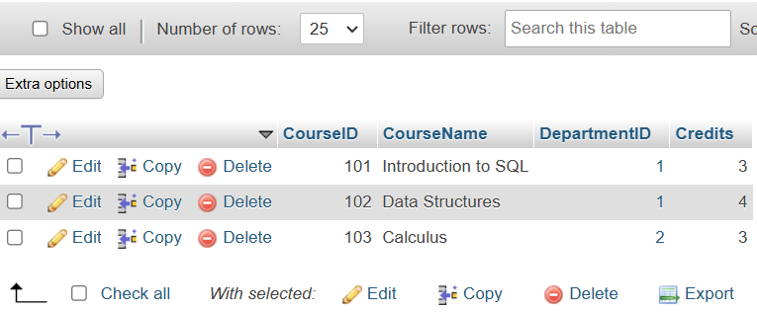
- Departments
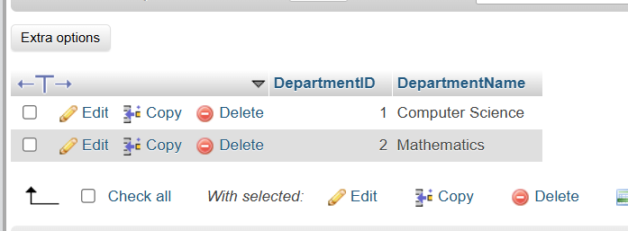

- Enrollments


- instructors
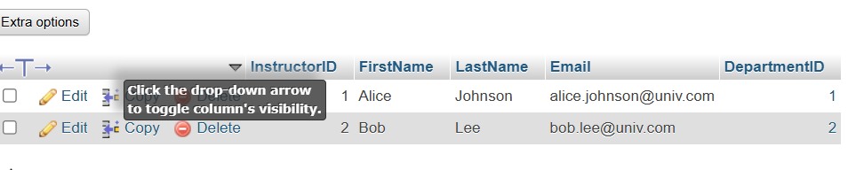

- studens

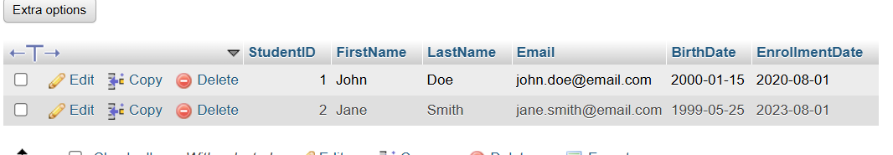

Query
↓
Execute
↓
Output
↓
Screenshot

professional order:
Cover Page
↓
Introduction
↓
Objective
↓
Database Design
↓
Tables & Fields
↓
Sample Data Screenshots
↓
SQL Queries + Output Screenshots
↓
Conclusion

